## **Hands-On Activity: Working with conditions**

**TOTAL POINTS 2**

1.

Question 1



## Activity overview



In previous activities, you used basic spreadsheet functions such as COUNT, SUM, AVERAGE, and MAX. In this activity, you will work with the conditional versions of these functions: COUNTIF, SUMIF, AVERAGEIF, and MAXIFS.

Conditional functions are functions that perform a specific task on an array, but only on those cells in the array that satisfy some defined criteria. They are usually identified with an IF suffix adjoined to the desired operation. They are frequently used when constructing more complex queries that cannot be accomplished using more basic functions.

By the time you complete this activity, you will be able to use conditional functions and understand when and why they are appropriate. This will enable you to do more complex analysis with spreadsheets as you continue to develop your data analyst’s skill set.



### What you will need

To get started, first access the Working with Conditions spreadsheet.

Click the link to the spreadsheet to create a copy. If you don’t have a Google account, you may download the spreadsheet directly from the attachments below. Make sure to select “Use Template” on the downloadable item.

Link to spreadsheet: [Working with Conditions](https://docs.google.com/spreadsheets/d/1jOgeCHTF4nDBWWNmNRLtdWZoO53r5K5g9uDCULUEc4Q/template/preview)

OR

Download spreadsheet:

[Working with Conditions.xlsx](https://d3c33hcgiwev3.cloudfront.net/TP0HEtBSRZK9BxLQUtWSdw_2d90471b8d4d49d58e6d845ef38b17f1_Working-with-Conditions.xlsx?Expires=1623369600&Signature=WyBwZoWj1FGvc1ktf1XbxervTpA1tkhOC3GLRtmooZFvnGtc6gWsDcHXWvc71jJN4RzJEz9kEFGrUu5YvIt0zRuOlszZVrSEVoQ44V0w94kN2qrkkN2eOMRPbrZ0txTv-iT5yawTokoavxWvOVufX-Vqw0hbH3wV-cuDGbLjS~8_&Key-Pair-Id=APKAJLTNE6QMUY6HBC5A)

[](https://d3c33hcgiwev3.cloudfront.net/TP0HEtBSRZK9BxLQUtWSdw_2d90471b8d4d49d58e6d845ef38b17f1_Working-with-Conditions.xlsx?Expires=1623369600&Signature=WyBwZoWj1FGvc1ktf1XbxervTpA1tkhOC3GLRtmooZFvnGtc6gWsDcHXWvc71jJN4RzJEz9kEFGrUu5YvIt0zRuOlszZVrSEVoQ44V0w94kN2qrkkN2eOMRPbrZ0txTv-iT5yawTokoavxWvOVufX-Vqw0hbH3wV-cuDGbLjS~8_&Key-Pair-Id=APKAJLTNE6QMUY6HBC5A)

This data set has seven columns and 20 rows (not including the headers). The contents are several metrics pertaining to a fictitious team of salespeople.

## Use the COUNTIF function



First, open the Working with Conditions spreadsheet.

Suppose you want to calculate the number of salespeople that the company has in New York state. The COUNTIF function allows you to do this easily. The syntax the COUNTIF is =COUNTIF(range, criteria).

The range is the array of cells that you are checking and the criteria is what you are checking for. All cells in the array that match the provided criteria will be counted and this number returned as the value of the function.

To use this function to count the number of salespeople working from “NY,” click on an open cell. In the function bar, type =COUNTIF(B2:B21, "NY").

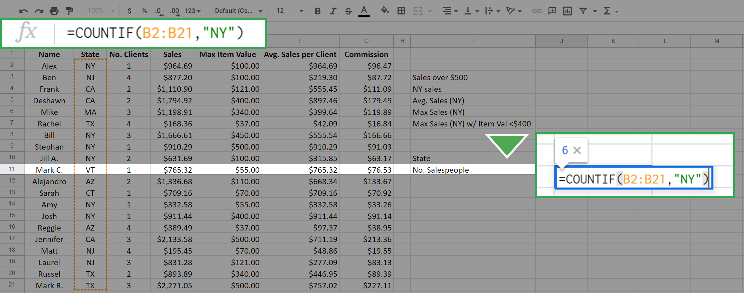

Notice you've entered the range as the array of cells from B2 to B21. This is all from column B with the exception of the column header. The function checks all cells in this array against the value “NY” (entered in quotes) which is the criteria. Every cell in this array with a value of “NY” will be counted, and the result is returned in the cell. It is 6 in this case.

Press Enter (Windows) or Return (Mac). The result should display like this:

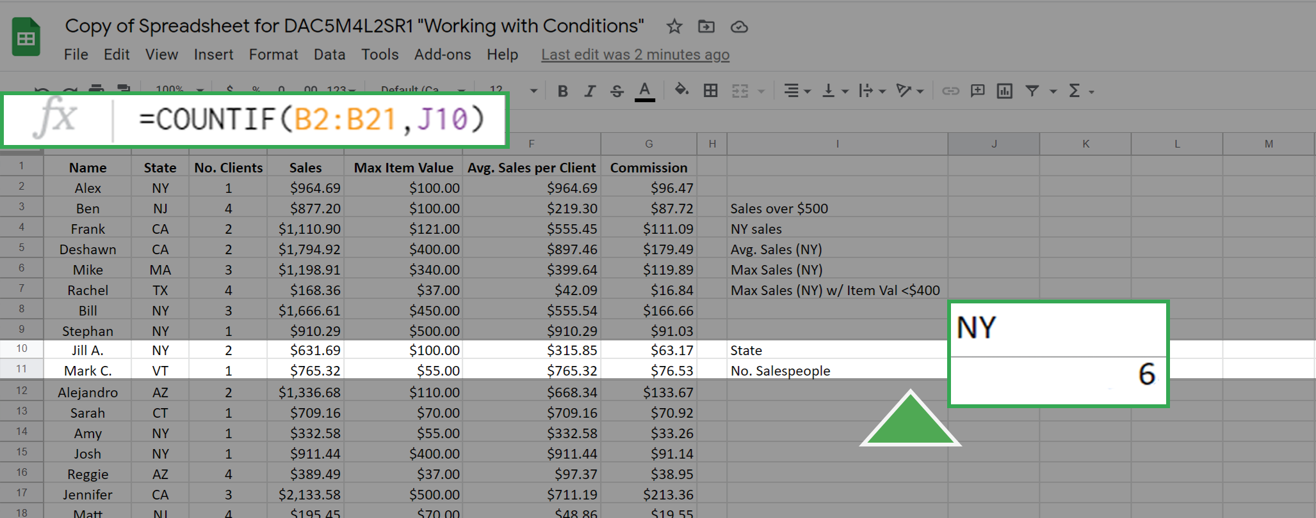

As an alternative to entering the criteria "NY" into the COUNTIF function, you can achieve the same result by entering a cell address as the criteria. The function will then use the value of the cited cell as the criteria. For example, the cell J10 has the value "NY." If you enter this in the function bar the COUNTIF function will seek out the value in cell J10 and use it as the criteria. This gives the same result as before:

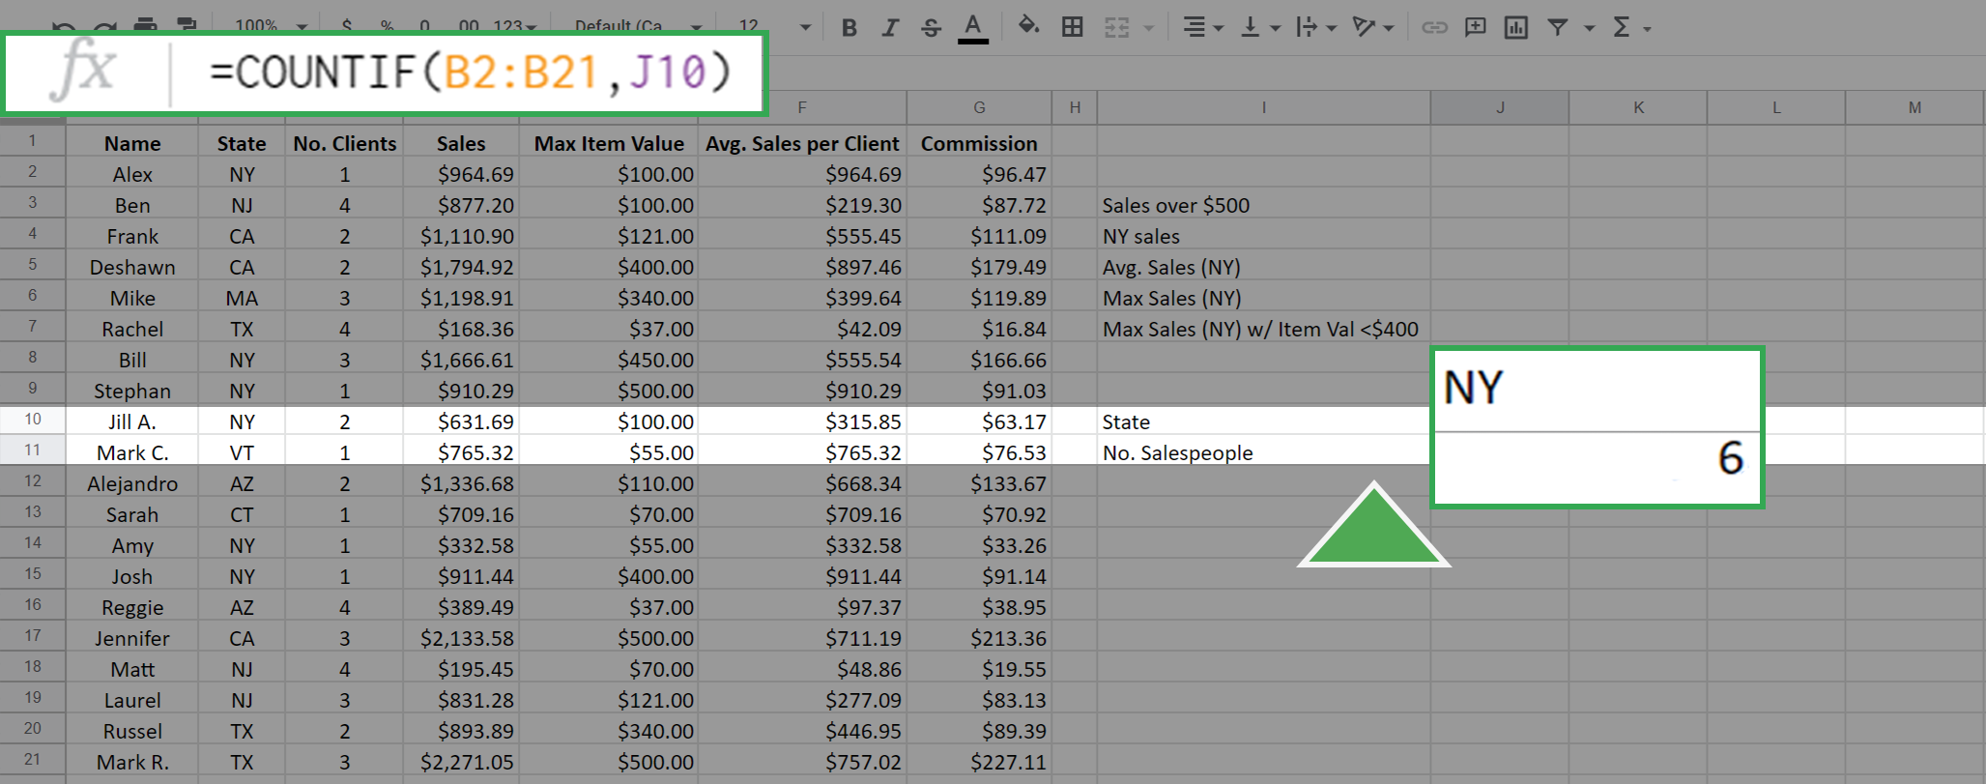

## Use the SUMIF function



The SUMIF function is used to create a sum of the values of cells that meet a specific criteria. It supports the logical operators (>, <, <>, =). The syntax for this function is =SUMIF(range, criteria, [sum_range] ).

The inputrange is the array of cells that you check against the value of criteria. The sum_range is the array of values that you will sum up if the criteria is met. In this syntax above, the square brackets around sum_range indicate that this input is optional. However, you do not add square brackets when writing the function. If the argument sum_range is absent, then the SUMIF will sum the values in range by default.

As an example of this function, suppose that you want to create a sum of all sales more than $500.00. This can be executed as =SUMIF(D2:D21, ">500").

The result is:

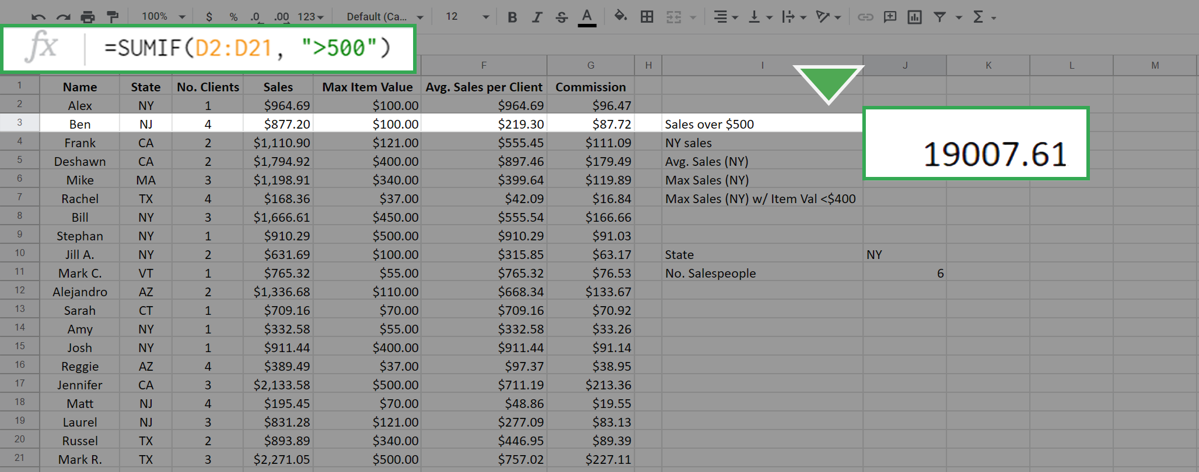

Because you didn't include the sum_range input, all the values in the cells D2 to D21 that match the criteria were summed by default. To sum only the sales from New York, but not restrict to those greater than $500, type the following function: =SUMIF(B2:B21, "NY", D2:D21).

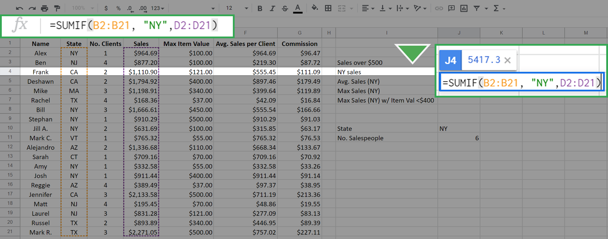

This results in:

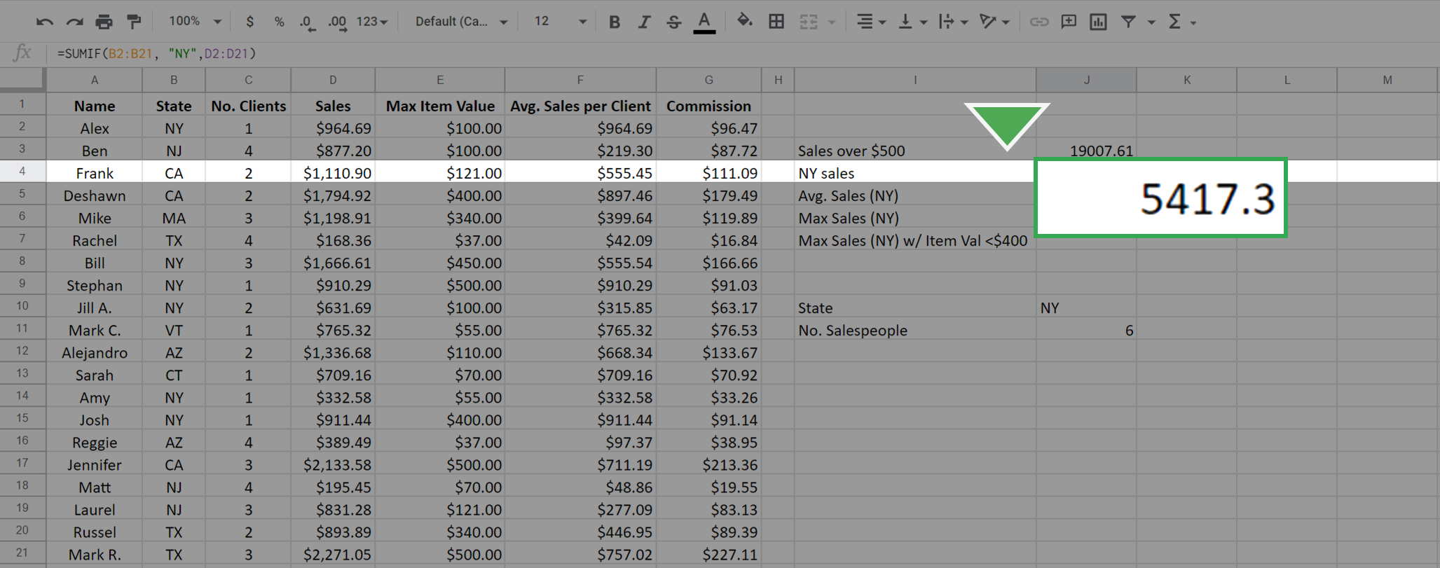

Notice that in the SUMIF, the first input, B2:B21, is the range of cells that are checked for the criteria "NY" and the summing is done across the sum_range of cells D2:D21 that have the state meeting the criteria "NY." This is different than in the first case. In that case, the array that you check is the same array that you sum across.

### Use the AVERAGEIF function



Just like the previous two functions, the AVERAGEIF function will average the values in an array based on a given criteria. The syntax is =AVERAGEIF(range, criteria, [sum_range]).

The inputs to this function, range, criteria, and sum_range, work in exactly the same manner as in the SUMIF function. Again, the sum_range is optional.

Now, find the average sales per salesperson in New York. Type the following function: =AVERAGEIF(B2:B21, "NY", D2:D21).

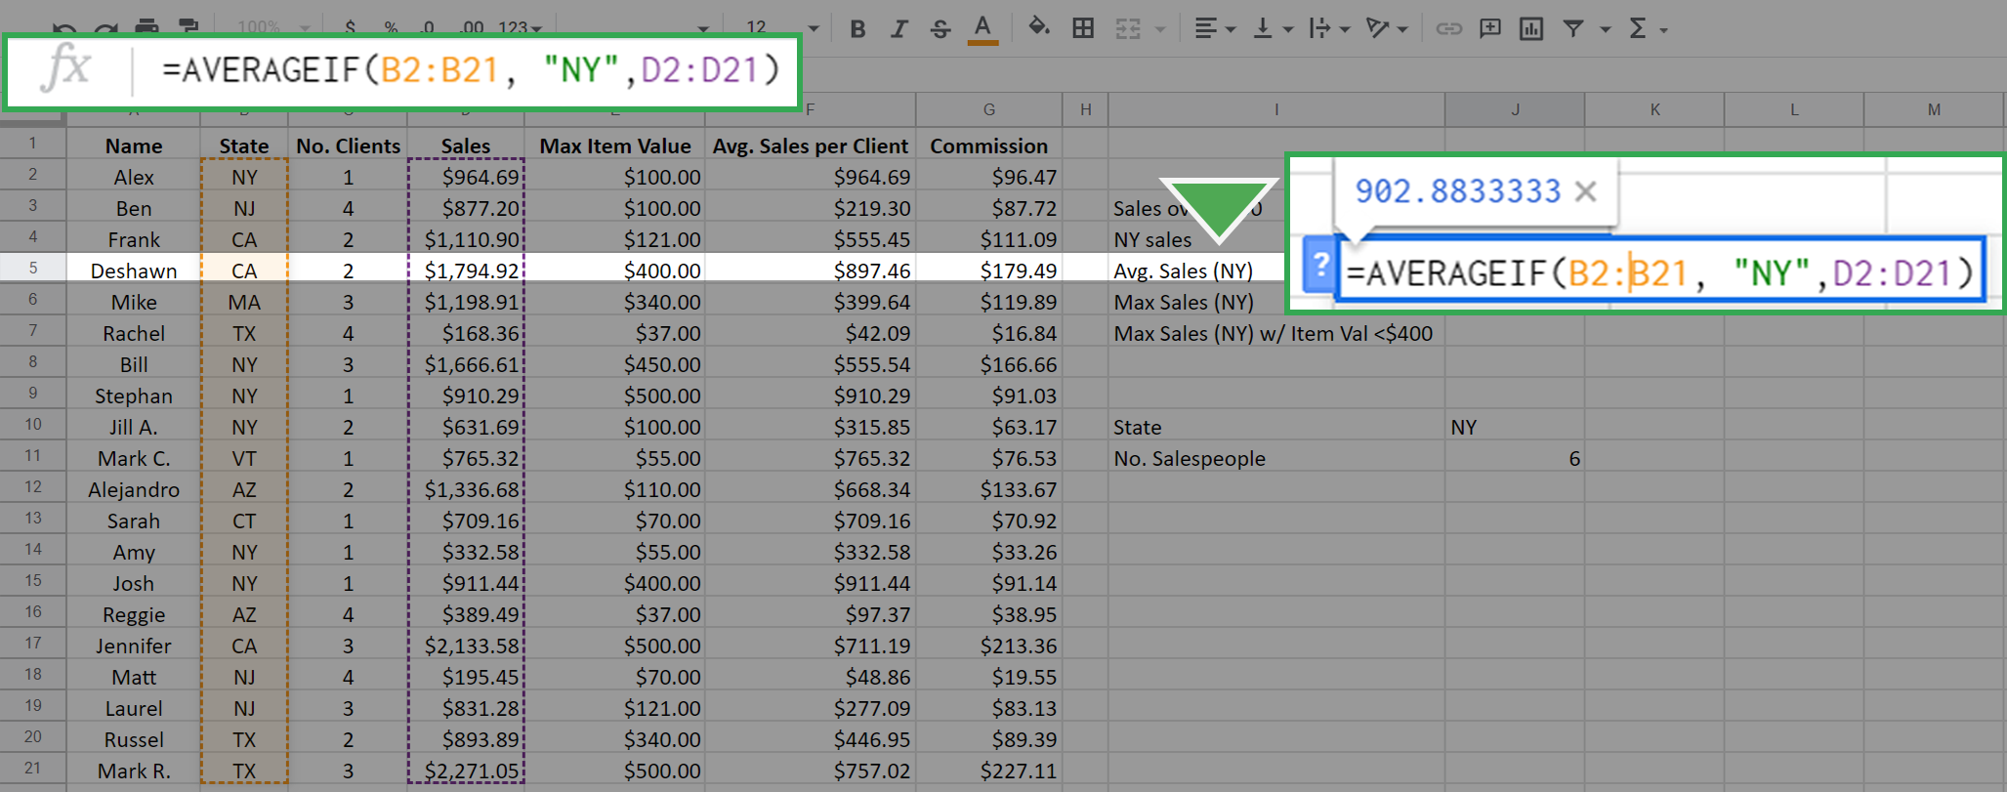

This yields 902.83333 as the result.

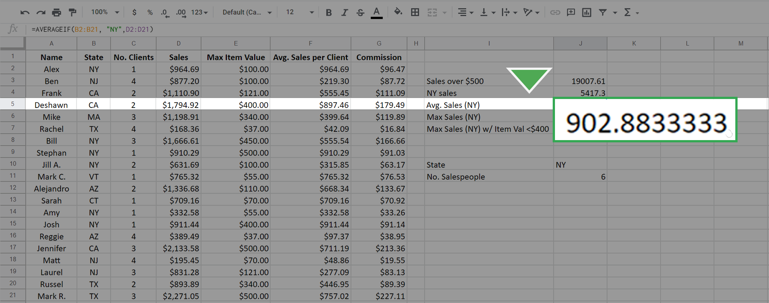

## Use the MAXIFS function



The MAXIFS function is slightly different from the other three functions. The easiest way to observe the difference is to examine the syntax: =MAXIFS(max_range, range1, criteria1, [range2], [criteria2], ...).

* Note for Microsoft Excel users: MAXIFS can only be used with an Office 365 subscription on Excel 2016 or newer. If you cannot use a version of Excel that allows the function MAXIFS, please use Google Sheets for this part of the activity.

The first argument, max_range, is the array over which you are finding the maximum. The second argument (range1) is the array you are checking. The third argument (criteria1) is the value that you are checking for. The inputs in the square brackets are for optional additional constraints.

Use this function to find the maximum sales from any salesperson in New York. Type the following: =MAXIFS(D2:D21, B2:B21, "NY").

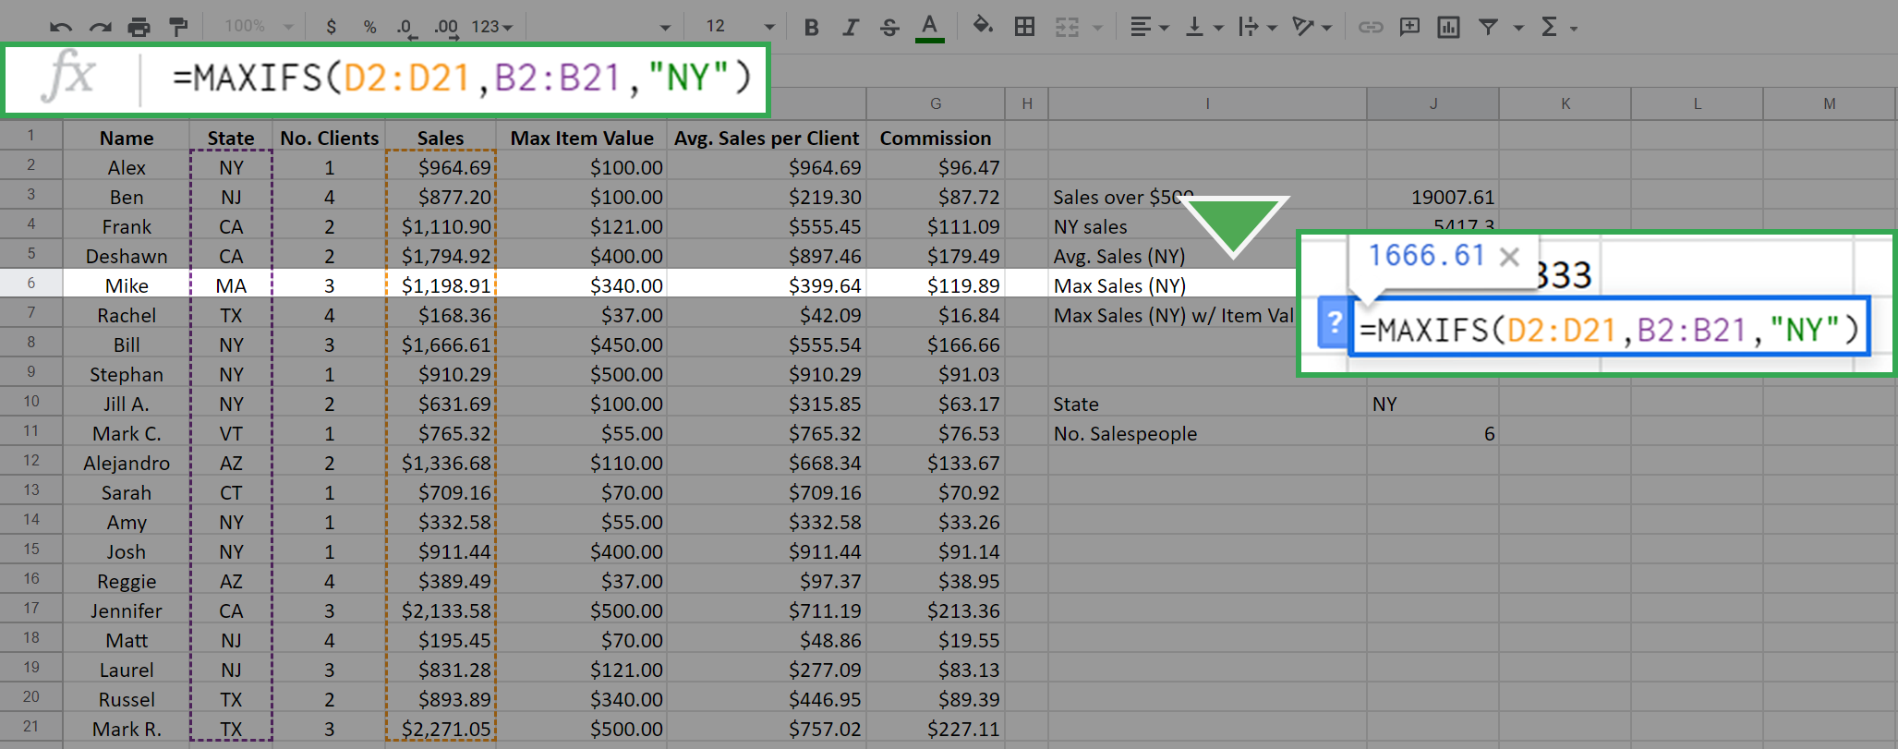

The resulting calculation is 1666.61.

Remember, the order in which you enter the inputs matters. Try reversing the position of the arrays from the first example and type =MAXIFS(B2:B21, D2:D21, "NY").

The result is 0.

This is because you are asking the function to find the maximum of the array B2:B21 where the sales equal "NY". This is impossible because the values in the array D2:D21 (the sales array) are numerical. Therefore, none of them equals "NY," which is a string. The function returns 0 when nothing in the range meets the criteria.

The MAXIFS function can input more than one constraint. This is where the optional range2 and constraint2 come into play. Additional constraints follow the logic that every constraint must be satisfied for a cell in the max_range to be considered.

For example, to find the maximum sales in New York where the Max Item Cost is below $400, type the following into the function bar: =MAXIFS(D2:D21, B2:B21, "NY", E2:E21, "<400").

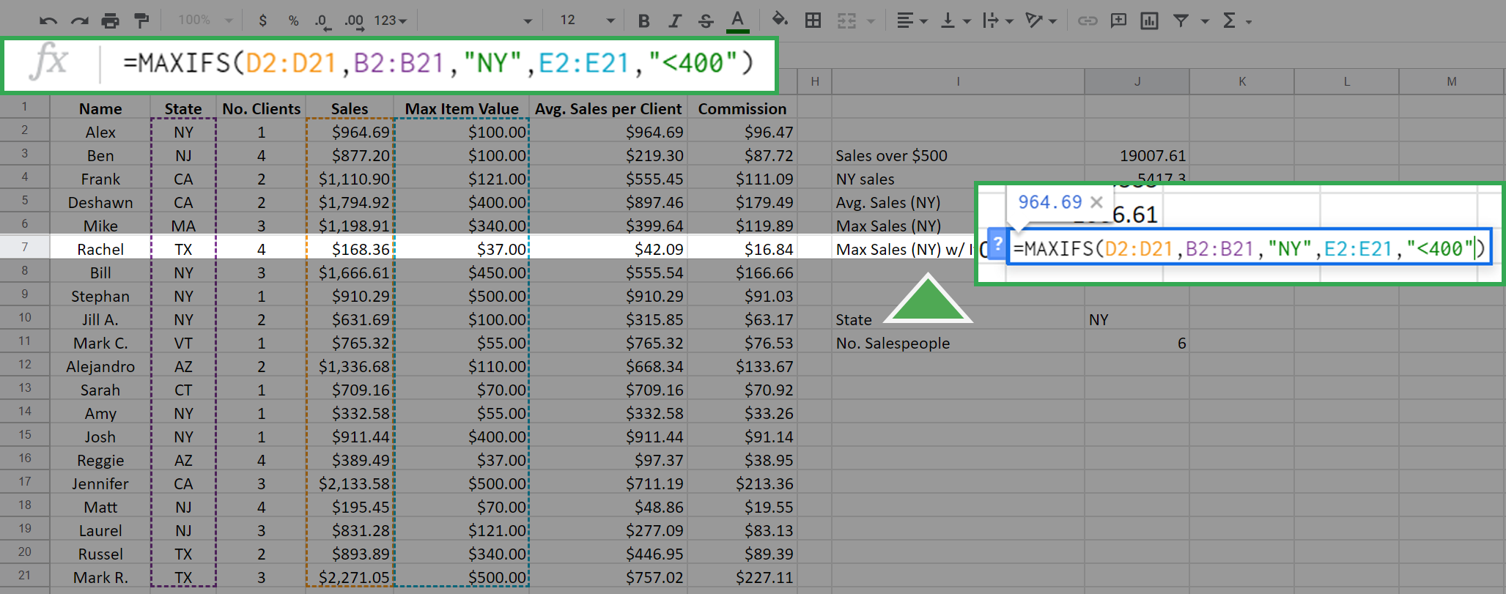

The first three inputs are the same as above, but now you've added the additional constraint that Max Item Value must be less than $400. The array E2:E21 is the Max Item array and its cells are checked against the criteria <400. The function returns the following, which is the maximum sales of any New York salesperson who did not sell any single item over (or equal to) $400.

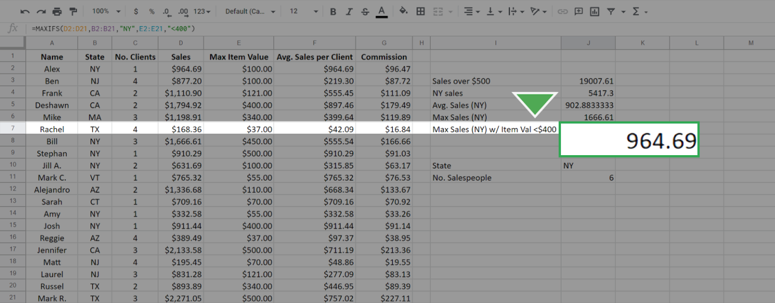

Each of the previous functions—COUNTIF, SUMIF, and AVERAGEIF—have equivalents that work similarly to MAXIFS. These include COUNTIFS, SUMIFS, and AVERAGEIFS. The syntax and functionality of these functions, apart from the specific calculation, are identical to MAXIFS. For example, the SUMIFS function will give the sum for single and multiple constraints just like MAXIFS function does for the maximum. It also has the same syntax as MAXIFS.

## Confirmation and reflection



In this activity, you tested the query =COUNTIF(B2:B21, "NY"), which returned the value 6. Suppose you want to determine how many of those 6 salespeople have only 1 client. You run the query =COUNTIFS(B2:B21, "NY", C2:C21, "1") to find this information. What value does this return?

**1 / 1 point**

1

4

3

5

**Correct**

The query =COUNTIFS(B2:B21, "NY", C2:C21, "1") returns the value 4, since there are 4 salespeople in New York that have only one client. To find this information, you used the COUNTIFS function with additional constraints. Going forward, you can use other conditional functions to find specific information from your data, which will help you carry out more complex analyses.

2.

Question 2

In this activity, you used functions with multiple conditions to answer questions about your data. In the text box below, write 2-3 sentences (40-60 words) in response to each of the following questions:

* How can you use conditional statements with functions to create complex queries?
* When is it appropriate to use a function with multiple constraints, such as MAXIFS, rather than a function with a single constraint, such as MAXIF?
* What are some other situations where you might prefer to use a conditional function instead of a regular one?

**1 / 1 point**

we can use for example the coutifs, maxifs, averageifs and so one to create a complext queries.

**Correct**

Congratulations on completing this hands-on activity! A good response would include how conditional statements can be used to create complex queries and functions to perform tasks on an array that meets one or more criteria.

The suffix -IF is a common syntax addition that will allow you to implement more complex queries and functions. Many of the basic functions allow for an -IF and most of those also allow -IFS as well. By using these more complex functions, you can expand your spreadsheet skillset and analyze data more effectively in programs like Google Sheets and Microsoft Excel.